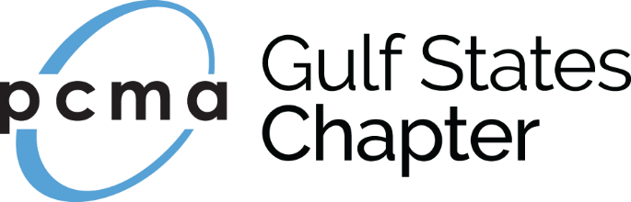

Win a Scholarship to
PCMA Convening Leaders in Nashville!
January 7-11, 2018
Our Chapter is proud to offer an opportunity to send one Professional Member to Convening Leaders.
The selected recipient must agree to submit a blog post on their experience at Convening Leaders for Gulf States Chapter and serve in a leadership capacity on board or committee for the Gulf States Chapter in 2018.

Please share with us your contact information and your qualifications to be considered as the recipient of this registration and travel scholarship.

Name: _______________________________________
Designation(s): ______________________
Title: ________________________________________
Organization: _______________________
Business Address: ________________________________
Preferred Phone: _________________________
E‐mail: ________________________________
PCMA Member Since: _____________

I feel I would be deserving of the 2018 Scholarship because (you may enlarge this section if necessary):

I understand that I am obligated to serve in a leadership role or on a chapter committee in 2018.
(Initial here) _________
Leadership Position or Committee(s) I would consider serving on:

Do you have the approval of your immediate manager/supervisor to attend Convening Leaders if chosen? YES/NO

Please email to GulfStates@PCMA.org.

Deadline is August 30, 2017

